Risk Card Game

**Product’s Description**

The product team has designed a simple turn-based decision-making game with the following description. For each game cycle, the player starts with an initial balance and has to spend a small amount from his balance to initiate a game. Then the player goes through consequent rounds where he is presented with four hidden cards. Only three are winning cards, so the player is given the option to either take the risk and reveal a card or forfeit. If the player chooses to reveal a card and wins, the card’s score is multiplied by the round number and added to the winning pool for that game cycle. If the player reveals the losing card, the winning pool is discarded and the game cycle ends. On the other hand, if the player chooses to forfeit, the winning pool is added to his balance and the game cycle ends. Winning cards have a fixed score value and are stacked in a deck, from which 3 random cards are drawn each round and are shuffled back in after the round ends. The winning pool should be cleared at the start of a game cycle.

**Software Architecture**

The flowchart of the product’s logic is shown below:

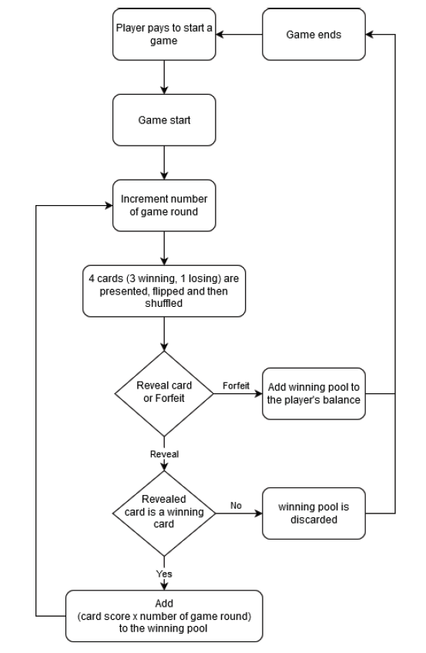

**Execution Instructions**

In order to execute the code locally we do the following steps

i) we clone the project from the github repository ()

ii) into the game folder we open a terminal or a cmd

iii) we execute npm start

iv) the app will be accessible from a web browser at localhost:3000

**To be debugged:** Currently the flip of the cards is bugged, only the first and the third one can be flipped, while the second and the fourth can proceed the game to the win or lose. Also the round and winning balance values are not adding up properly.